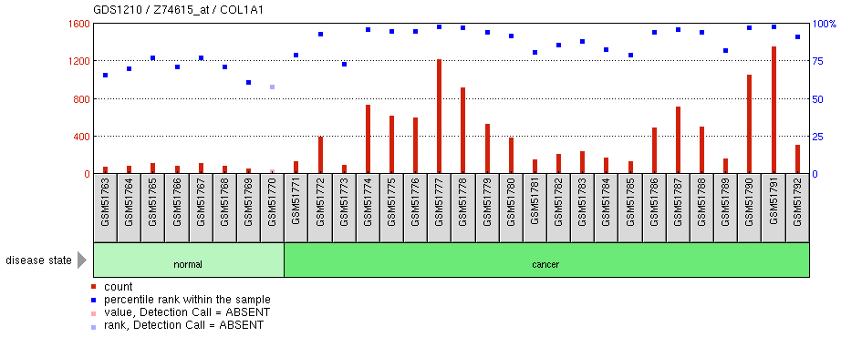

|  |  |  |  |  |
| --- | --- | --- | --- | --- |
| **Title:** | Gastric cancer | | | Cluster Analysis[GDS1210 Cluster Image](http://www.ncbi.nlm.nih.gov/geo/gds/analyze/analyze.cgi?ID=GDS1210)Download |
| **Summary:** | Expression profiling of 22 primary advanced gastric cancer tissues. Whole gastric cancer tissues examined in the presence of metastasis and according to histological type. Results provide insight into the progression and diversity of gastric cancer. | | |
| **Organism:** | [Homo sapiens](http://www.ncbi.nlm.nih.gov/Taxonomy/Browser/wwwtax.cgi?mode=Undef&lvl=0&srchmode=1&name=Homo%20sapiens) | | |
| **Platform:** | [GPL80](http://www.ncbi.nlm.nih.gov/geo/query/acc.cgi?acc=GPL80): [Hu6800] Affymetrix Human Full Length HuGeneFL Array | | |
| **Citation:** | * Hippo Y, Taniguchi H, Tsutsumi S, Machida N et al. Global gene expression analysis of gastric cancer by oligonucleotide microarrays. Cancer Res 2002 Jan 1;62(1):233-40. PMID: [11782383](http://www.ncbi.nlm.nih.gov/pubmed/11782383) | | |
| **Reference Series:** | [GSE2685](http://www.ncbi.nlm.nih.gov/geo/query/acc.cgi?acc=GSE2685) | **Sample count:** | 30 |
| **Value type:** | count | **Series published:** | 2005/05/22 |

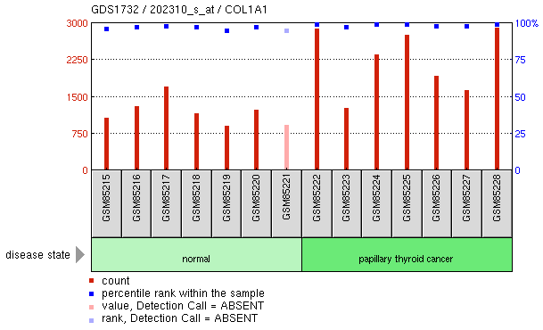

|  |  |  |  |  |
| --- | --- | --- | --- | --- |
| **Title:** | Papillary thyroid cancer | | | Cluster Analysis[GDS1732 Cluster Image](http://www.ncbi.nlm.nih.gov/geo/gds/analyze/analyze.cgi?ID=GDS1732)Download |
| **Summary:** | Expression profiling of 7 papillary thyroid carcinoma (PTC) samples. PTC is the most common type of thyroid cancer, representing up to 80% of all malignant thyroid tumors. Results provide insight into potential molecular markers for PTC. | | |
| **Organism:** | [Homo sapiens](http://www.ncbi.nlm.nih.gov/Taxonomy/Browser/wwwtax.cgi?mode=Undef&lvl=0&srchmode=1&name=Homo%20sapiens) | | |
| **Platform:** | [GPL570](http://www.ncbi.nlm.nih.gov/geo/query/acc.cgi?acc=GPL570): [HG-U133_Plus_2] Affymetrix Human Genome U133 Plus 2.0 Array | | |
| **Reference Series:** | [GSE3678](http://www.ncbi.nlm.nih.gov/geo/query/acc.cgi?acc=GSE3678) | **Sample count:** | 14 |
| **Value type:** | count | **Series published:** | 2006/06/30 |

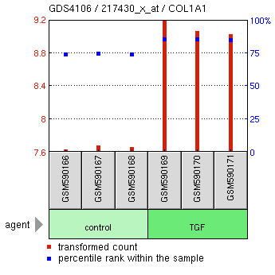

|  |  |  |  |  |
| --- | --- | --- | --- | --- |
| **Title:** | Transforming growth factor beta effect on Panc-1 pancreatic adenocarcinoma cell line | | | Cluster Analysis[GDS4106 Cluster Image](http://www.ncbi.nlm.nih.gov/geo/gds/analyze/analyze.cgi?ID=GDS4106)Download |
| **Summary:** | Analysis of Panc-1 cells treated with TGFβ to induce epithelial-mesenchymal transition. During EMT, cancer cells lose epithelial specific proteins and gain mesenchymal proteins to acquire migratory/invasive phenotype essential for metastasis. Results provide insight into molecular basis of EMT. | | |
| **Organism:** | [Homo sapiens](http://www.ncbi.nlm.nih.gov/Taxonomy/Browser/wwwtax.cgi?mode=Undef&lvl=0&srchmode=1&name=Homo%20sapiens) | | |
| **Platform:** | [GPL570](http://www.ncbi.nlm.nih.gov/geo/query/acc.cgi?acc=GPL570): [HG-U133_Plus_2] Affymetrix Human Genome U133 Plus 2.0 Array | | |
| **Citation:** | * Maupin KA, Sinha A, Eugster E, Miller J et al. Glycogene expression alterations associated with pancreatic cancer epithelial-mesenchymal transition in complementary model systems. PLoS One 2010 Sep 27;5(9):e13002. PMID: [20885998](http://www.ncbi.nlm.nih.gov/pubmed/20885998) | | |
| **Reference Series:** | [GSE23952](http://www.ncbi.nlm.nih.gov/geo/query/acc.cgi?acc=GSE23952) | **Sample count:** | 6 |
| **Value type:** | transformed count | **Series published:** | 2010/09/03 |